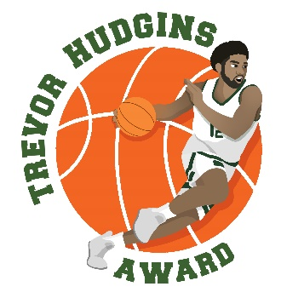

2023-24 Trevor Hudgins Award Watch List
25 Players

Josh Angle, Claremont-Mudd-Scripps
Drew Blair, MN-Duluth
Anthony Brown, MidAmerica Nazarene
DJ Campbell, Stockton
Jack Clement, Otterbein
Vinny DeAngelo, Swarthmore
Tyler Dearman, Guilford
Wes Dreamer, NW MO State
Jesse Hafemeister, Catholic
Jake Hilmer, Upper Iowa
Jahn Hines, Christopher Newport
Jeff Hunter, Keene State
Zach Laput, Bentley
KJ Jones, Emmanuel (GA)
Josiah Johnson, Mary Hardin-Baylor
Ryan Jolly, Piedmont
Elijah Malone, Grace
Jayvon Maughmer, Cedarville
Anthony Mazzeo, Case Western Reserve
Christian Parker, Mount Union
Ethan Porterfield, IUP
Tyler Schmidt, Olivet Nazarene
Jeremiah Sparks, Oswego State
Zach Toussaint, West Texas A&M
Malik Willingham, Minnesota State

